Ministry of Education of the Republic of Belarus

Institution of Education
Belarusian State University
of Informatics and Radioelectronics

Faculty of Information Technologies and Control

Information Technologies in Automated Systems Department

Diploma project submission permitted
The Head of the Information Technologies in Automated Systems Department

____________А.А. Naurotsky

EXPLANATORY NOTE
Diploma Project

Automated Mobile Payment System
BSUIR 1-53 01 02 01 009 DP

Student |  | Tu Xinyuan
Supervisor |  | A.F.Trofimovich
Advisors:
- from the Information Technologies in Automated Systems Department |  | A.F.Trofimovich
- for the Economic feasibility study |  | I. V. Smirnov
Standards Compliance Inspector |  | N. V. Batin
Reviewer

Minsk 2022

CONTENTS
Introduction 3
1. ANALYSIS OF SUBJECT AREA 5
1.1 Aim And Objectives Of The Project 5
1.2 Organizational Structure and Design of Payment System 5
1.3 Scope of the study 7
1.4 Existing Student Housing Information System 8
1.5 Proposed Mobile Payment System 9
2. DESIGNED APPLICATION STUCTURE OF MOBILE PAYMENT SYSTEM 10
2.1 Selection of Design Methodology 10
2.2 Implementation of the Mobile Payment System 11
2.3 IDEF0 DIAGRAM 14
2.4 UML Use Case and Sequence Diagrams of the Mobile Payment System 16
2.4.2 Sequence diagram 18
2.4.3 Collaboration diagram 20
2.4.4 Activity diagram 20
2.5 Design and Description of the Database System 22
2.6 System Hardware and Software Requirements 23
2.7 Ergonomics 23
3. INFORMATION SYSTEM SOFTWARE IMPLEMENTATION 25
3.1 Software implementation Programming Tools 25
3.2 Software Structure 25
3.3 Code Description 25
3.4 User’s Guide 25
3.5 Administrator’s Guide 25
3.6 Software Installation 25
3.7 Test Cases 26
3.8 Further Development 26
4. ECONOMIC FEASIBILITY STUDY 27
4.1 Characteristic of an Economic Case of the Project 27
4.2 Calculation of cost of materials for project “Automated Task Management System at the Enterprise” 27
4.3 Calculation of a base salary of the personnel occupied with Accomplishment of Works Under the Project 27
4.4 Calculation of an additional salary of the contractors 27
4.5 Calculation of the Project Taking Into Account the VAT Under the Formula 27

INTRODUCTION

Mobile payment, also named as mobile money, mobile money transfer and mobile wallet, generally refer to payment services executed on the mobile terminals. Compared to the traditional payment with cash, cheque and credits cards, mobile payment show advantages on wide range of applicability, security and convenience. Further, better interactive experience is provided in mobile payment. Also, in terms of anti money laundering and fund trackbility, mobile system is more effective.
In general, there are four main models for mobile payments:
- Bank-centric model
- Operator-centric model
- Collaborative model
- Independent service provider(ISP) model

In the first and second models, a bank or the operator is the central node in the mobile payment system, managing the transactions and distributing the property rights. In collaborative model, the financial intermediaries and telephonic operators collaborate in the managing tasks and share cooperatively the property rights. IN ISP model, a third party agency of confidence operates as an independent and neutral intermediary between financial agents and operators. Apple Pay or PayPal are the typical ISP mobile payment provider.
A mobile wallet is an app that contains the user’s debt and credit card information, letting them pay for goods and services digitally via their credit cards directly or indirectly. Notable mobile wallets include:
- Alipay
- Apple Pay
- Google Pay
- WeChat Pay
- Samsung Pay

Alipay is a third party mobile and online payment platform, established in China, is the combination of Operator-centric model and ISP model, which provide internal financial system as well as external bank communication services. Google Pay and Apple Pay are purely ISP providers and only play role as invoking services provided by bank systems to make transactions.
In Belarus, the mobile payment development is at initial stage, with few proportions of population. Still lot of people prefer to use traditional payment. With digitization tendency, mobile payment will replace traditional payment gradually. Small merchants can enjoy the benefits brought by mobile payment, since the mobile payment doesn’t rely on the POS-alike machine which is the necessary transaction component.
The goal of this project is to create a new mobile android app and its correspond backstage management system in web page. The process of the app is described roughly as below.
An user can login into the system by their account. Inside system, services including exporting money, importing money, transfer, receive and pay are provided. By providing valid merchant information, an user can register to be an merchant, unlocking relevant business functions which include analysis of business income and its visualization graph, unlimited receiving payment and calling the system API.

ANALYSIS OF SUBJECT AREA

Aim And Objectives Of The Project
The purpose of the automated mobile payment system is to facilitate the process of payment between users and merchants, and the transfer among users. In such system, user can pay by scanning the QR code provided by merchant, and they can also import and export their funds, check their bill records and register to be an merchant. For merchant, the automated system provides them with various services, including setting QR code to receive payment, checking income and outcome, and embed the payment system inside their own system as payment intermediate.

The goal of this project is to create an android application called mobile payment, a web project for merchant, another web project for administrators and relevant databases.
In detail, there are three entrance clients in the system, which consist of one android application for users and merchants to operate basic operations, one web application for merchant to embed the system’s API and the other for administrator to manage the system.
The figure below ( Figure 1.1 ) illustrates the components that the system needs to implement.

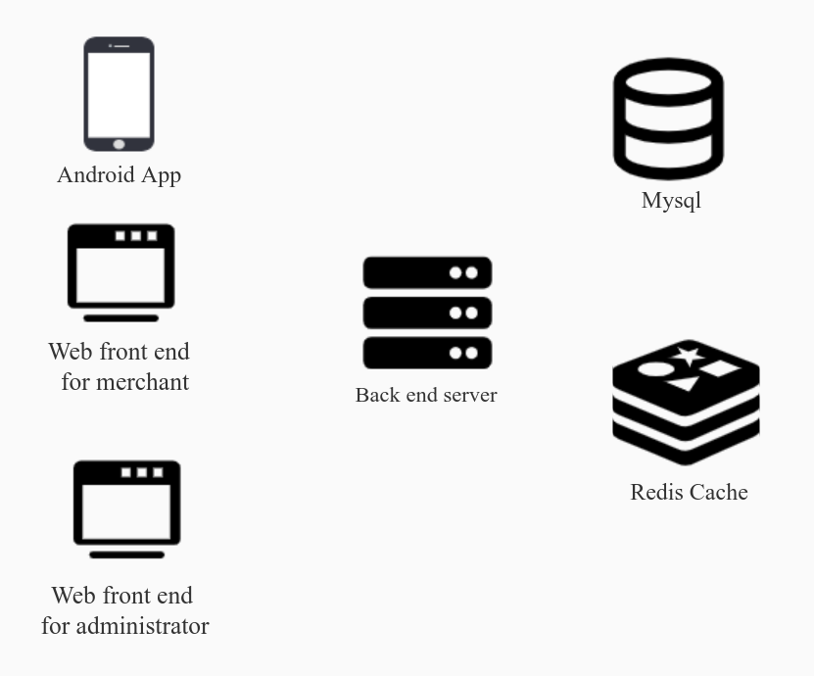

Figure 1.1 - components needing implementing

Organizational Structure and Design of Payment System
An organizational structure is a pattern or network of relationships that exist among positions. It is a pattern of relationships that has been generated through a conscious planning process. Key executives typically decide upon the basic pattern of structure that in their opinion will be most appropriate for themselves, their work, and organization goals.

1.2.1 The Importance of Organizational Structure
The Importance of Organizational Structure
- Clear definition of authority, responsibility relationship facilities better understanding of the objectives and the policies of the enterprise.
- Organizational structure lays down both channels and the patterns of communication. It facilitates proper administration.
- It helps to coordinate activities of the component parts in order to facilitate the realization of the goals of the organization.
- It helps in growth and diversification of the activities of an organization.
- Workers, participation in organization increases their cooperation and improves their will to work. It stimulates initiation and creative thinking.
- Implementation of policies and the achievement of the goals become easier.
- It prevents duplication of functions and makes it possible to achieve maximum production with minimum efforts.

1.2.2 Approaches to Organization, Structure and Management
Organization structure, the process of management and the behavior of people at work are inextricably linked. Underlining the development of management theory and practice are contrasting ideas on structural design and attitudes towards people. Identification of major trends in the study of organizations and management will help to provide a perspective on concepts and ideas.

1.2.3 The Value of Organization Charts
It is usual for the structure of the payment system to be depicted in the form of an organization chart. This can be very useful in providing a pictorial presentation of the structural framework of the roles and its main area of activities. It is helpful, for example, as part of a staff induction manual. The chart may also be used as a basis for the analysis and review of structure, for training and management succession, and for formulating changes.
An organization chart may show, at a given point in time, how work is divided, spans of control, the levels of authority, lines of communication, and formal relationships. But charts vary greatly. Some are intended to give a minimal amount of information, perhaps for example only an outline of the management structure of the payment system.
Every payment, needs an organizational structure to carry its operation. It is used to help divide tasks, specify the job for each role, and also define permissions. Effective job specifications will increase work productivity and efficiency. Each payment organizes workforce in different way. The following shows a the organization structure. See figure 1.2 below

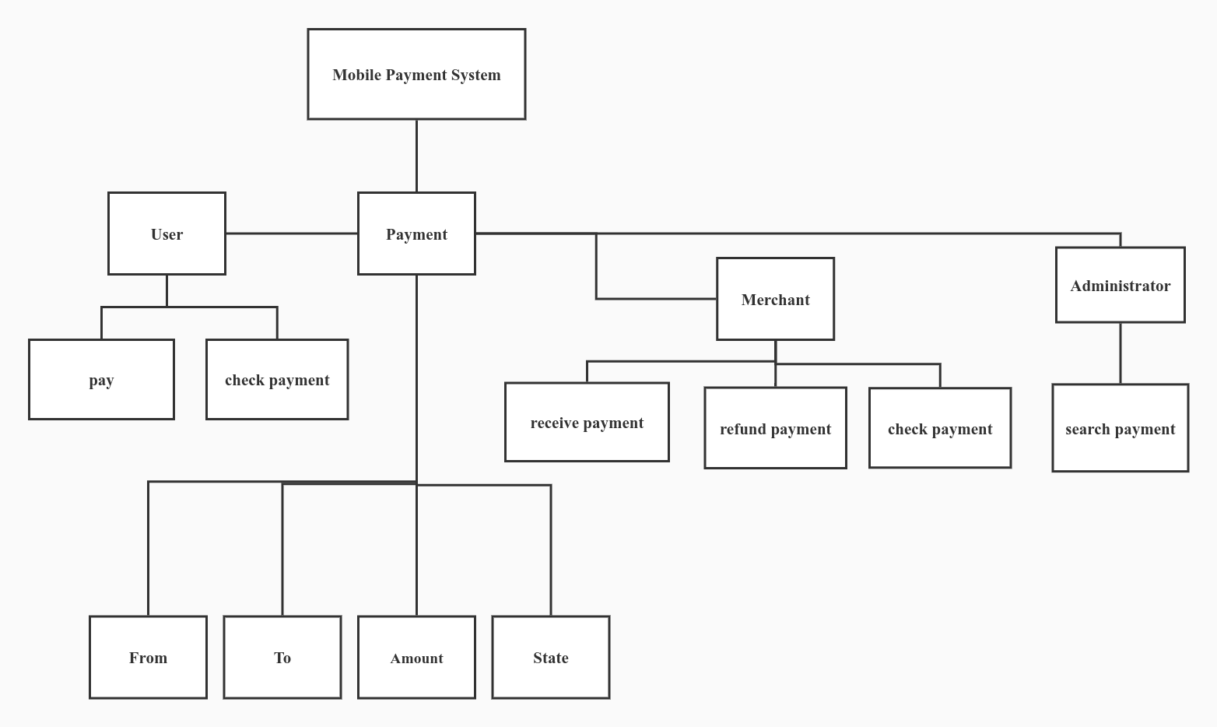
Figure 1.2 – Organizational Structure Mobile Payment System

The structure is system from which merchants can set payment link to receive fund and users can pay via the payment link offered. Moreover, merchants and users can both check the payment record. For merchants, one additional function ‘refund payment’ is provided.For regulations of payment, administrators have permissions to search all the payment made.

Scope of the study
The mobile payment consist of four types, which of them are Bank-centric, Operator-centric, Collaborative and Independent service provider(ISP). The proposed system is ISP (Independent service provider) model, which provides internal fund operation as the transaction is made. Also, the system records transaction which can be applied as source for audit process. Though the transaction is made online, the national tax law still works. The system stores the statistics of merchants and if needed, it can provide tax collecting services.
As for finance security, both for individuals and enterprises, it would be better if the system is capable to determine the user’s real identity and limit each registered identity to only one unique account. Transactions with illegal or suspected illegal can be easily tracked to real identify. To do this, the system must have a way to identify user. Verification methods during registration is applied. Before submitting identify information, users must complete their email and mobile phone, which the system will automatically send verification code later. Only filling the correct code can the user process. After submitting identity data, the administrators of the system must check the correctness and validity of the information submitted by user, which includes passport number, passport photo, first name , last name and nation. If the administrator rejects the registration, the registration will be canceled. Otherwise, if he accepts, the user registration is successfully finished. Eventually, every uses corresponds to one real identity. Users can sign up for merchant using the same account. The verification for merchants is similar. In verification, merchant name, merchant license number and merchant license photo must be provided, and the business entity must be the same of the user account.

Existing Mobile Payment System
The are varieties of mobile payment system nowadays. Most of them are payment system based on ISP model, which heavily replies on credit card or debit card system.
The following section describes the existing mobile payment systems and its pros and cons.

Drawbacks of the Existing Systems
As previously mentioned, majority of the existing mobile payment systems are relying on credit card or debit card system and use the protocols or interfaces provided by card organization(Eg. Master card or Visa) or certain banks. However, when there exists errors, like server crush inside the bank system or unreachable internet access, payment failed. Obviously, the outer financial system does influence the mobile payment. The mobile payment applications that may encounter such situations are Apple Pay, Google Pay ..etc.
Another mobile payment system having its own internal transaction system is Paypal. Paypal has its own balance system. It can import fund from credit cards, letting user transfer balance from other bank systems. Nevertheless, its ergonomics is not perfect. To make payment, user has to manually input the Email address of the merchant, in which it’s potential to input the wrong email address. Another disadvantage is that there is no effective method to determine the user’s identity in the system. There may be cases where users laundry illegal funds by making transaction, which can be hard to track. Possibly, when some business is conducted on traditional mobile payment apps, due to the anonymity, taxes can be avoided by using multiple accounts for income gaining.

PayPal
PayPal Holdings, Inc. is an American multinational financial technology company operating an online payments system in the majority of countries that support online money transfers, and serves as an electronic alternative to traditional paper methods such as checks and money orders. The company operates as a payment processor for online vendors, auction sites and many other commercial users, for which it charges a fee.

AliPay
Alipay is a third-party mobile and online payment platform, established in Hangzhou, China in February 2004 by Alibaba Group and its founder Jack Ma. Alipay overtook PayPal as the world's largest mobile payment platform in 2013. As of 31 March 2018, the number of Alipay users reached 870 million. It is the world's number one mobile payment service organization and the second largest payment service organization in the world. According to the statistics of the fourth quarter of 2018, Alipay has a 55.32% share of the third-party payment market in mainland China, and it continues to grow.
Alipay is conceptually similar to Apple Pay, WeChat Pay and PayPal because it overlays traditional card payment methods. The main feature of AliPay is that it supports QR Code payment. Moreover, it also supports flesh face recognition as authentication method, which guarantees the security.

1.5 Proposed Mobile Payment System

A proposed mobile payment is supposed to have following features:
- The system has its internal balance system,in other word its own bank system, which means the system can still generate transaction without outer bank system.
- The system supports import and export of fund, which may include adding balance from outer bank system
- The system provides flesh authentication for security. For example, face recognition can be offered for payment.
- The system is equipped with spy program spying on transaction, which may require strengthened authentication if the payment is unexpected according to the user’s history transaction analysis. For example, when the user pays huge amount of money which is seemingly impossible according to the analysis of the user’s payment history.
- The system contains notification for income and outcome of money.

DESIGNED APPLICATION STUCTURE OF MOBILE PAYMENT SYSTEM

Selection of Design Methodology
As per the project management there should be a proper selection of the methodology so on that contrast we have to select the methodology for the project i.e. Mobile payment system. The method being used in developing the system is the System Development Life Cycle (SDLC). The SDLC process includes project identification and selection, project introduction and planning, analysis, design, implementation and maintenance.

Purpose of Methodology
- it provides us with a framework for planning the project;
- the quality of a software development effort is improved using selected process techniques.

Structure of the methodology
The general structure of life cycle model is shown in the figure 2.1.
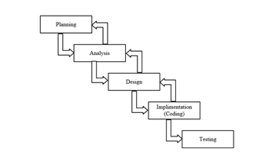
Figure 2.1 – Methodological Structure

Each phase produces deliverables required by the next phase in the life cycle. Some phases are also inter-related with other phase. Planning is done in the first and analysis of the system is continued after that. Analysis of the system is being translated into design. Code is produced during implementation that is driven by the design. Testing verifies the deliverable of the implementation phase.
Planning: It is the very first phase of the system, in which we decide what the task is for and what all things we have to do for completion of the project in an easier and healthy way.
Analysis: It is second and also considered as an important phase of the life cycle model. In this phase, the existing system is studied by collecting the information through the Internet and analyzed the information to get alternatives for the use of proposed system.
Design: This is where the details on how the system will work are produced. Architecture, including hardware and software, communication are all part of the deliverables of a design phase.
Implementation: This is the longest phase of the software development life cycle as the code is produced from the deliverables of the design phase during implementation.
Testing: During testing of the system, the implementation code is tested to make sure that the product is actually solving the needs addressed and gathering the other information. Unit testing and system testing are done during this phase.

Implementation of the Mobile Payment System
Implementing a mobile payment system mainly requires implementing of certain algorithms. In general, the algorithm has the following properties:

- discreteness. this property is that the algorithm must represent the process of solving a problem as a sequential execution simple steps. to perform each step of the algorithm, the final time interval, that is, the transformation of the original data into the result is discrete in time;
- definition. each algorithm rule must be clear, single-valued;
- efficiency. the algorithm should lead to a solution for finite number of steps;
- the mass. the algorithm for solving the problem is developed in general form, that is, it must be applicable to a certain class of problems, differing only in the initial data;
- correctness. the algorithm is correct if its execution gives correct results of solving the task.
There are different means to make algorithms. The choice of the tool is determined by the type of the algorithm to be executed. The following are ways of recording algorithms:
- Verbal: when the algorithm is described in human language.
- Symbolic, when the algorithm is described by a set of symbols.
- Graphical, when the algorithm is described using a set of graphic images. Common methods of recording are graphical recording using flowcharts.
- Versatility. The algorithm can be used for an entire class tasks, to different sets of initial data.

For this system, the key algorithm of mobile payment is the payment process between user and merchant where there is a confirmation from the merchant side. The data structure to implement this is below.

pay: a semaphore whose count is 1
confirmation: a semaphore whose count is 1
finish: a semaphore whose count is 1.

In figure 2.2 below is a flowchart describing such algorithm
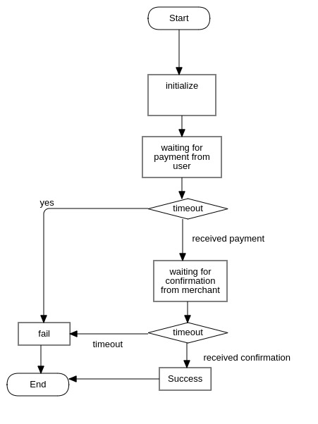

Figure 2.2 – System flowchart: user payment with confirmation

The payment process begins with initialization and then await until the some user made a payment. If the waiting process costs more than specified time, then the payment fails. Otherwise, when there is payment made, the algorithm waits for merchant confirmation, which can be sent from merchant business server. If there is a confirmation request during the scope of waiting time, the algorithm will do the final stage of the payment,which includes the persistence of certain data, make notification... etc.

IDEF0 DIAGRAM
IDEF0 (Integration Definitionincome for Function Modeling) is a function modeling methodology for describing manufacturing functions, which offers a functional modeling language for the analysis, development, reengineering, and integration of information systems; business processes; or software engineering analysis.IDEF0 is part of the IDEF family of modeling languages in the field of software engineering, and is built on the functional modeling language Structured Analysis and Design Technique (SADT).
The IDEF0 Functional Modeling method is designed to model the decisions, actions, and activities of an organization or system. In its original form, IDEF0 includes both a definition of a graphical modeling language (syntax and semantics) and a description of a comprehensive methodology for developing models. IDEF0 should assist in organizing system analysis and promote effective communication between the analyst and the student through simplified graphical devices.The diagram below shows the IDEF0 of a typical function in mobile payment system in figure 2.3 below.
The four arrow types, Inputs, Controls, Outputs and Mechanisms are collectively called ICOM and IDEF is an abbreviation of ICOM DEFinition. There is a zero on IDEF0 because there are a number of additional IDEF standards.The side of the activity box, which they touch, identifies the different ICOM arrows. Thus inputs are on the left, controls at the top, outputs on the right and mechanisms at the bottom.

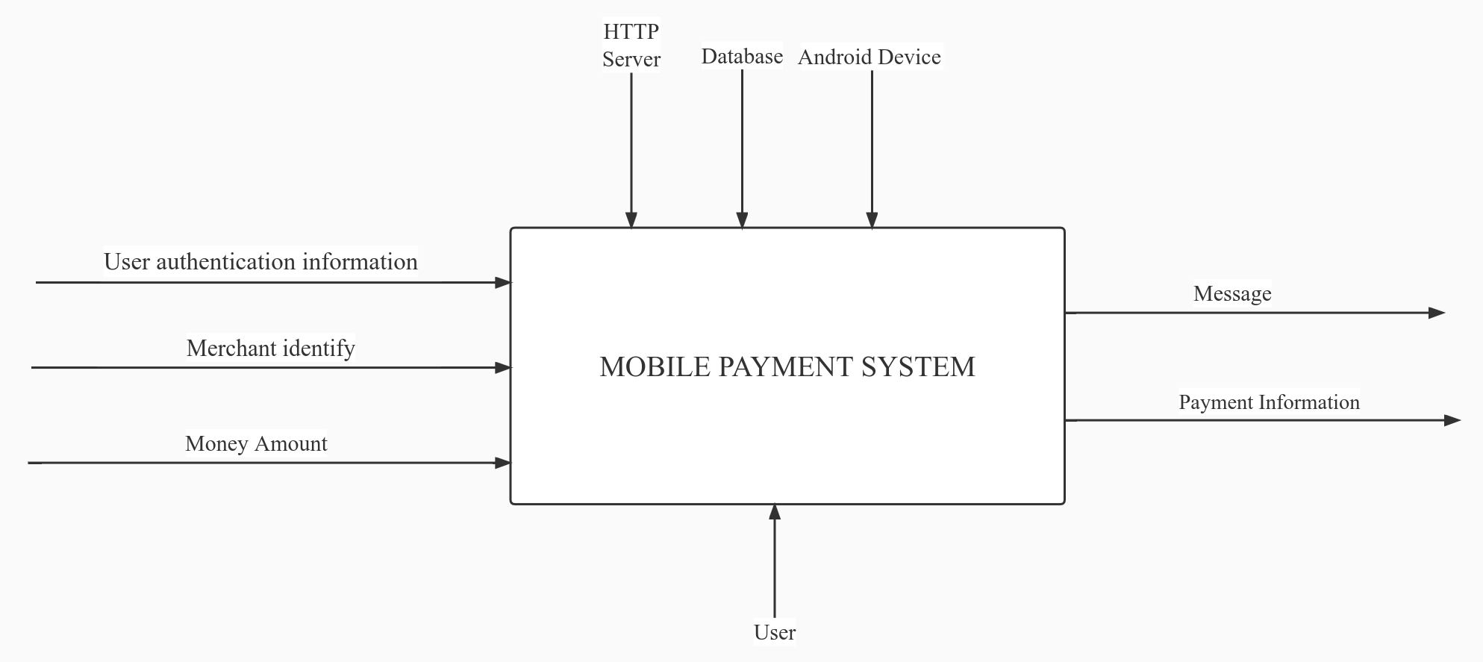
Figure 2.3 – Context diagram for mobile payment system

- This can make diagrams a bit more difficult to draw but can make them more easily readable.
- The system inputs are user authentication information, merchant identity information and valid money amount which is positive and has two decimal points.
- The system control are the Http server and Database, which provides business logic and persistence respectively.
- The system’s mechanism is the user.
- The system’s output contains payment information and message.

The diagram below (Figure 2.4) shows IDEF0 decomposition diagram for mobile payment

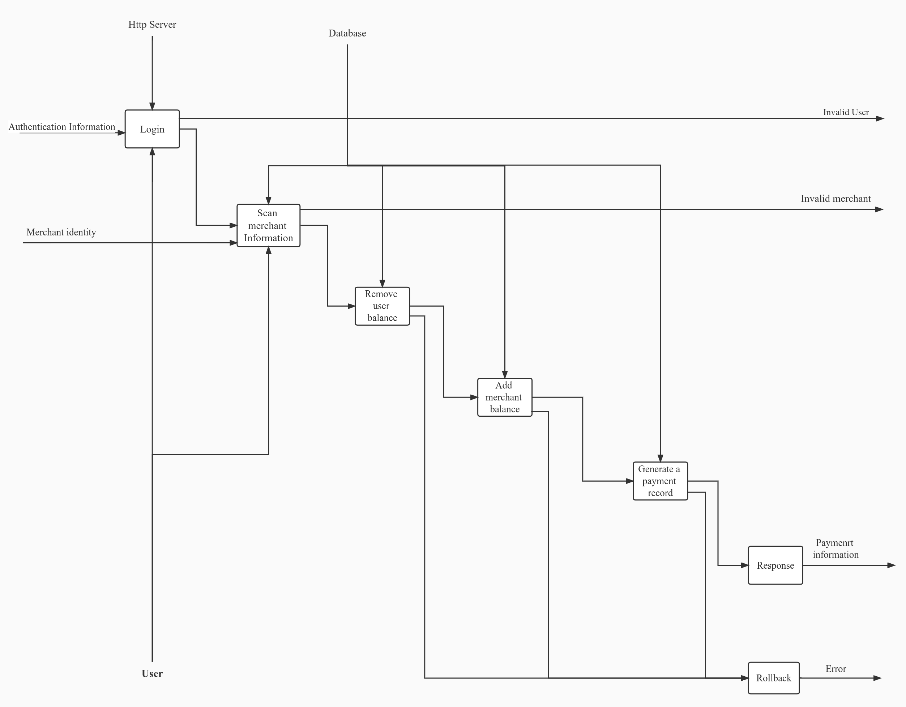

Figure 2.4 – Decomposition diagram of the System

In the function of payment, there are seven sub processes, which are Login, Scan merchant information, Add merchant balance, generate payment record, response and rollback. Firstly, the user need to login by providing certain authentication information, if the authentication is not correct, a message indicating invalid user is sent .Then the process scanning merchant information is needed, if the merchant identify can’t not be recognized, ‘invalid merchant message’ is sent. Afterwards, it comes to three transactional processes, which are Remove user balance, add merchant balance and generate payment record. If any of the above three processes, the it calls rollback process and send a ‘error’ message. Otherwise, it responses with successful payment information.

UML Use Case and Sequence Diagrams of the Mobile Payment System
For the description of the algorithm used in the system diagrams,UML is used.The UML (Unified Modeling Language) is a standard visual modeling language intended to be used for modeling business and similar processes, analysis, design, and implementation of software-based systems. UML is a common language for business analysts, software architects and developers used to describe, specify, design, and document existing or new business processes, structure and behavior of artifacts of software systems.

2.4.1 Use Case diagram
Use case diagramsare usually referred to asbehavior diagramsused to describe a set of actions (use cases) that some system or systems (subject) should or can perform in collaboration with one or more external user of the system (actors). Each use case should provide some observable and valuable result to the actors or other stakeholders of the system.

In this project, there are three actors, which are Administrator, User and Merchant. (Figure 2.5)
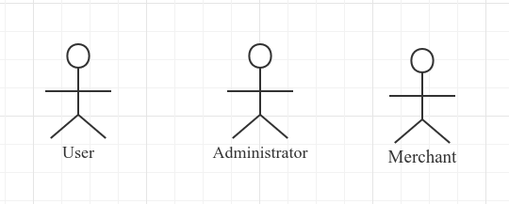
Figure 2.5 – Actors of the System

The User can register, apply to be a merchant, import fund, export fund, transfer fund, make a pay, check balance, check bill and receive fund.
The Administrator is the role for management in the system. He/She can freeze user account, freeze merchant account, freeze user balance, freeze merchant balance, verify user registration by either rejecting or accepting and verify merchant application either by rejecting or accepting.
The Merchant evolves from user, which is after user’s application and the administrator’s acceptance. He/She can export fund, check balance, check bill, receive fund and call the system’s payment API.
The diagrams below (Figure 2.6 and Figure 2.7) are the corresponding user case diagrams.
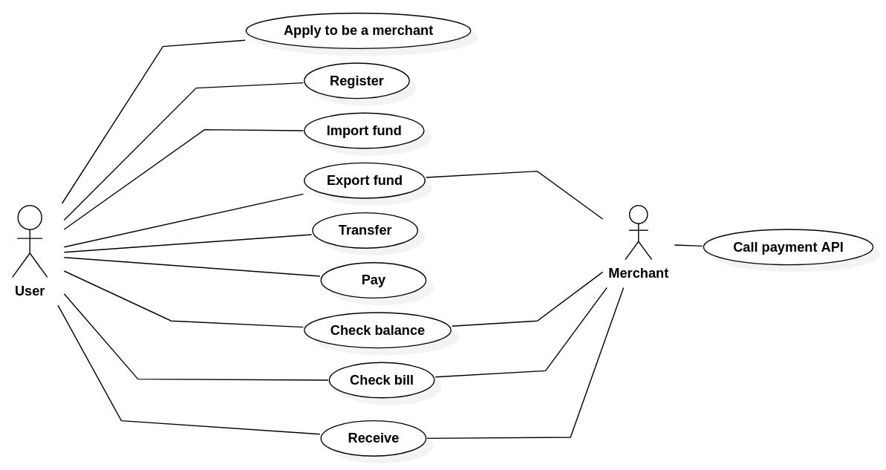
Figure 2.6 – User case diagram for User and Merchant

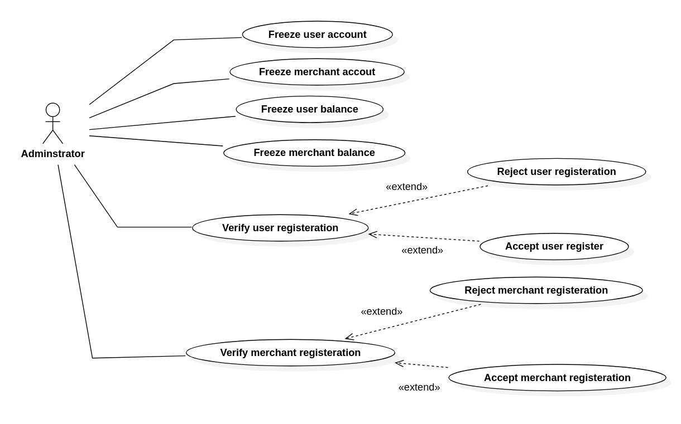
Figure 2.7 – User case diagram for Administrator

2.4.2 Sequence diagram
Sequence diagrams show how objects communicate with each other in terms of a temporal sequence of messages. The time flow is the most visible aspect in these diagrams, as messages are sequenced according to a vertical timeline and also the lifespan of objects associated to those messages is reported.

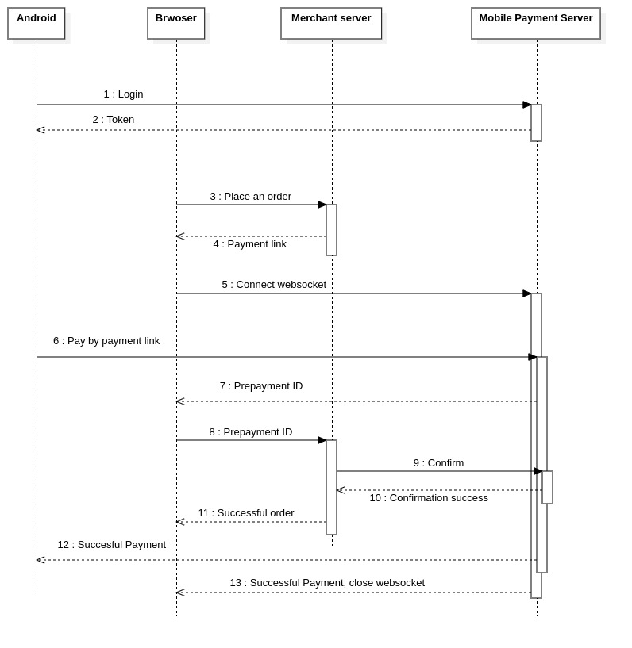
Figure 2.8 – Sequence diagram for payment with confirmation

The above diagram shows the interaction among android app, browser, merchant server and mobile payment server.
The sequence consist of following procedures:
- The user login into the system and fetch the token from mobile payment system.
- The user user browser to place an order at a merchant’s website and get a payment link of the merchant( usually a qr code picture). On loading the payment link, the browser automatically start websocket with mobile payment system.
- The user uses android app to resolve the payment link and pay, after clicking pay, the loading progressbar shows.
- As user pays, the websocket at the browser returns prepayment id which is used to send to merchant server for verification.
- The merchant send a request for prepayment id verification and confirmation. If the verification is without error, the order placement is done.
- Finally, the progressbar in procedure 3 ends with successful payment. The websocket ends with successful payment too.

2.4.3 Collaboration diagram
A collaboration diagram shows the interactions between objects or classes in terms of links and messages that flow through the links. This describes at the same time some kind of static structure (links and nodes) and dynamic behavior (messages) of the system.

2.4.4 Activity diagram
Activity diagram is another important diagram in UML to describe dynamic aspects of the system. Activity diagram is basically a flow chart to represent the flow from one activity to another activity. The activity can be described as an operation of the system.
So the control flow is drawn from one operation to another. This flow can be sequential, branched or concurrent. Activity diagrams deals with all type of flow control by using different elements like fork, join etc.
The diagram below shows the processes of using the mobile payment system. When loading the page, a user enter his/ her credentials using the login column, then he/she is allowed to transfer, pay, check balance and check bills.
The activity below ( Figure 2.9) illustrates more detail.

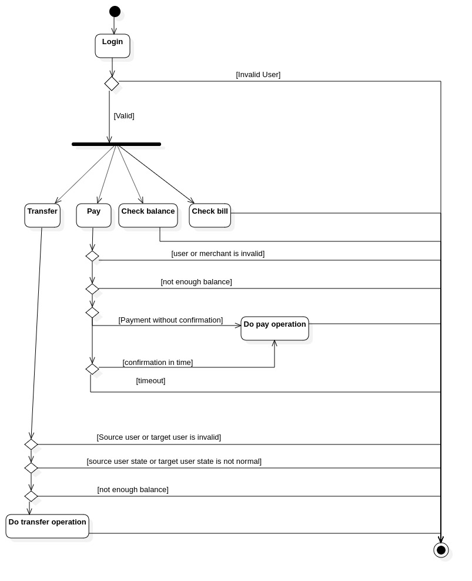
Figure 2.9 – Activity diagram

For transfer operation, firstly, the system checks the validity of the source user and target user by searching the database. If the result turns out invalid, the operation fails. Otherwise it then checks the state of the both users, on their account state, to see if their account is unverified or frozen. Afterwards, if the source user has sufficient balance, the transfer operation will start.
For payment operation, the procedures are similar. It checks the validity of merchant and user, and the user’s balance. Then if the payment needs no confirmation, it starts pay operation. Otherwise, it awaits until a confirmation occur in time. If no confirmation occurs in time, it will end up with failure.

Design and Description of the Database System
A database is a more complex object; it is a collection of interrelated stored data that serves the needs of multiple users within one or more organizations, that is, interrelated collections of many different types of tables. The motivations for using databases rather than files include greater availability to a diverse set of users, integration of data for easier access to and updating of complex transactions, and less redundancy of data.
Database design - is process of creating a database schema, and determining the necessary integrity constraints.
The main objectives of the database design are:
- to secure the database with all the necessary information;
- ensuring the possibility of obtaining all the necessary data requests;
- reducing redundancy and duplication of data;
- ensuring data integrity (correctness of their content): elimination of contradictions in the content of the data, with the exception of their loss. The database reflects information about a specific subject region.
A database schema represents the logical configuration of all or part of a relational database. It can exist both as a visual representation and as a set of formulas known as integrity constraints that govern a database. These formulas are expressed in a data definition language, such as SQL. As part of a data dictionary, a database schema indicates how the entities that make up the database relate to one another, including tables, views, stored procedures, and more (Figure 2.10).

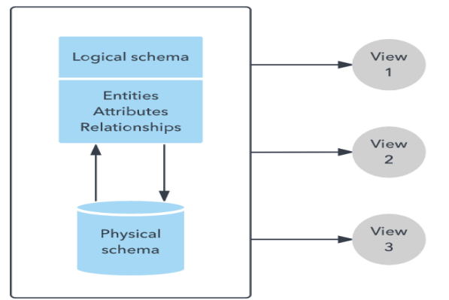

Figure 2.10 – Database Structure

Typically, a database designer creates a database schema to help programmers whose software will interact with the database. The process of creating a database schema is called data modelling. When following the three-schema approach to database design, this step would follow the creation of a conceptual schema. Conceptual schemas focus on an organization’s informational needs rather than the structure of a database.

System Hardware and Software Requirements
Hardware and System Software requirements gives us the insight for developing the system and the minimum requirements needed to run the developed system.
Server Software Requirement:
- Operating System: Windows XP/Vista/2000/Windows 8/10, Linux;
- Presentation layer: CSS, HTML, Javascript, Vue.
- Database: MySql;
- Runtime requirement: JDK 17.
Android Device Requirement:
- Operating System: Android with API >= 30.
- Android with back camera.
- Android with Internet access.
- Android with storage of more than 2.0G.
- Memory more than 1.5G.

Server Hardware Requirements:
The minimum requirements;
- Processor: Standard processor with a speed of 1.6 GHz;
- RAM:2 GB RAM or more;
- Hard Disk: 20 GB or more;

Ergonomics
The interaction of users with the systemwas carried out using Android and HTML. The interface of the system should be understandable and convenient, the system should not be overloaded with graphics and should provide a quick display of the screen. Navigation elements must be made in a user-friendly form. The means for updating information must satisfy the accepted agreements in terms of the use of function keys, operating modes, search, and use of the window system. The interface should correspond to modern Ergonomic requirements and provide easy access to the main functions and operations of the system.
The system should ensure correct handling of emergencies caused by incorrect user actions, invalid format or invalid input values. In these cases, the system must issue the appropriate messages to the user, and then return to the operational state that preceded the invalid (inadmissible) command or the incorrect data entry. Screen forms should be designed taking into account the requirements of unification:
All the screen forms of the user interface must be executed in a single graphic design, with the same arrangement of the main controls and navigation;similar symbols, buttons and other control (navigation) elements should be used to indicate similar operations. The terms used to denote typical operations (adding an information entity, editing the data field), as well as the sequence of user actions when executing them, must be unified;
The external behavior of similar interface elements should be implemented identically for the same type of elements. The system must meet the requirements of ergonomics provided that it is equipped with high-quality equipment .

INFORMATION SYSTEM SOFTWARE IMPLEMENTATION

Software implementation Programming Tools

Software Structure

Code Description

Module 1

Module 2

Module 3

Module 4

User’s Guide

Procedure for Registration

Procedure for Searching Goods

Procedure for Purchasing

Administrator’s Guide

Procedure for Registration

Procedure for Product Management

Procedure for User Management

Software Installation

Test Cases

Further Development

ECONOMIC FEASIBILITY STUDY

Characteristic of an Economic Case of the Project

Calculation of cost of materials for project “Automated Task Management System at the Enterprise”

Calculation of a base salary of the personnel occupied with Accomplishment of Works Under the Project

Calculation of an additional salary of the contractors

Calculation of the Project Taking Into Account the VAT Under the Formula

